UML class diagrams with Graphviz

[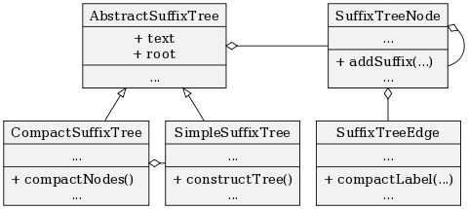](https://fsteeg.files.wordpress.com/2006/11/uml-class-graphviz.png)

Class diagrams can be created with Graphviz quite nicely: hierachical structure, reversed arrows, empty arrowtails and records as node shapes, pretty compliant. Code follows, rendered result above.

digraph hierarchy {  
size="5,5"  
node[shape=record,style=filled,fillcolor=gray95]  
edge[dir=back, arrowtail=empty]

2[label = "{AbstractSuffixTree|+ text\n+ root|...}"]  
3[label = "{SimpleSuffixTree|...| + constructTree()\l...}"]  
4[label = "{CompactSuffixTree|...| + compactNodes()\l...}"]  
5[label = "{SuffixTreeNode|...|+ addSuffix(...)\l...}"]  
6[label = "{SuffixTreeEdge|...|+ compactLabel(...)\l...}"]

2->3  
2->4  
5->5[constraint=false, arrowtail=odiamond]  
4->3[constraint=false, arrowtail=odiamond]  
2->5[constraint=false, arrowtail=odiamond]  
5->6[arrowtail=odiamond]  
}